The Pink Frosting House
Kay Wetzel Smith
I thought I would try to capture the house in this story as it was many years ago.

On the outside of Grandma’s or Mom’s house (as we grandchildren called her), looked like a house painted with pink frosting. It was really pink stucco. There was a front stoop sided with pink walls. A large picture window faced out to the street. No one’s house I’d seen had stained glass, but Mom’s did – a semi-circle on top of her picture window. The front grass had moss roses of pink and yellow every summer. The drive to the garage was not paved and the grass grew up where the car wheels never touched.

We never used the front door above the front stoop. We always went to the side stoop near the garage. Mom’s kitchen window looked out this direction and sometimes she would be peering out as we walked up the steps. The side stoop was a place the adults would hang out in the summer. They could sit on the ledges as if they were benches. Once, during the 4th of July, I remember one of the adults leaving a cigarette butt on the ground and it was still lit. We (Cindy, Vanessa, and I picked it up – we were in our teens) tried to smoke it. Just about that time Uncle Gale comes around the corner and snickers. Of course, we sheepishly put it down.

We cousins played in her small-grassed back yard. Sometimes, when we asked, we would eat the rhubarb that grew along the edge of her yard. I liked to look at all the flowers in Mom’s garden. Mostly I remember the big beautiful pink peonies with ants opening the petals. Sometimes we cousins would swing or try to acrobats on Mom’s clothesline.

Way in the back of the yard – not really very far but behind the garage, sat an old black Model A or T. We would have fun climbing on top and inside. I think it belonged to Uncle Jim.

Because there were so many of us cousins – I can’t remember how many but at least thirty something – we often were outside. It was too noisy when were all inside. Mom used to say, “Children should be seen and not heard.”

Usually during holidays, like Christmas or Thanksgiving, only a few cousins like the Wetzels, Alan Abbeys and the Gustafsons, were around (since some lived in Montana and Minnesota).

When you walked in the side door, you were in a hallway that led to the small kitchen and dining room. Right to the left on the wall, as you walked into the kitchen, was a red metal-rimmed clock. It became a present or gag gift many years later among the Abbey children that got given away whenever someone could pawn it over to the lucky Abbey brother or sister. It was a noisy clock that buzzed as the little hand moved around. Underneath the red clock was a beige stepstool – one place the lucky cousin who found the chair could sit.

The family spent many hours gathered around Mom’s kitchen table talking, eating and playing cards – especially Liverpool Rummy – ‘cause more people could play just by adding more decks of cards. The older cousins were eventually allowed to play Liverpool Rummy. We always waited for Mom to bring out her stash of candy during the games.

Mom was a very good cook and could make something taste good out of even her leftovers. On holidays, she would always make this fruit salad – I don’t remember all of the ingredients, but it used canned peach pie filling, pineapple, and fruit cocktail, for sure. Mom’s “bar” on holidays was next to the kitchen sink. The older cousins got to have Tom & Jerry’s with brandy or wine. The Tom part was fluffy white eggnog with nutmeg sprinkles. Mom’s wine was always Mogen David.

Because we lived in Beulah, we seldom stayed at Mom’s house. Once we stayed when our little sister, Marsha was born. Mom made us the best macaroni and cheese at night. In the morning, the toast was real special. Who ever remembers it like this? She took a 2-pronged meat fork, stabbed the bread and hung it over the electric stove burner, toasting each side separately – U-m-m. Sometimes when my cousin Vanessa came to town, I got to spend the night. It was hard to believe that 6 girls shared the eave-dropped upstairs room. One summer, Aunt Colleen slept in one bed near the window and Vanessa and I slept in the other bed. Colleen had the radio blasting next to her and the window open. I thought, so this is the curious thing that happens when you become a teenager! The Abbey boys slept in the other room – there were only 3 of them. In front of the window sat an old stand that I admired. It was because it had a pretty copper lining. But… I think Uncle Alan had Playboys in it! We found his other hiding place, too – in the little door under the eave and bed.

Back downstairs was the living room with the stained glass window and a wool burgundy or red-colored Oriental rug. There was a picture of our Grandpa Oran above the television. Next to the living room was Mom’s bedroom and a front room. The front room had a picture of some cherubs (became very popular in the 90’s because of angels and the modern cherubs were a copy of this old one). There were always African Violets with purple flowers in the room. I always liked seeing live plants. Mom also always had a sprig of some plant in a water glass in her kitchen window to start a new plant. More importantly, in the front room, was a piano. Though I never took lessons for very long, I always loved hearing others play. When Aunt Donna came home, she would play from ear. My fondest memories were at Christmas when we gathered around the piano and sang Christmas carols. Another mainstay in this room was a sheet music storage table. It was fun to look through the old songs and try to play them. One sticks out – “By the Light of the Silvery Moon.” Many years later, I was given 2 of Mom’s old sheet music. I still have them – framed.

Mom’s bedroom was very small – barely room for her double bed, mirrored-dresser and 6-foot high wardrobe. We cousins liked to look through her jewelry she had sitting out on her dresser. I think it was mostly costume jewelry. My favorite was her large pink sparkling earrings. One year when I was trying to find something to wear with my prom dress, Mom came up to our house with those pretty pink earrings and I wore them!

I have covered most of the house now – for purposes of memory. The house was just a house. The memories were there because of all the fun we cousins and aunts and uncles had in Mom’s house. We learned what I meant to be family in this house – laughter, love, teasing.

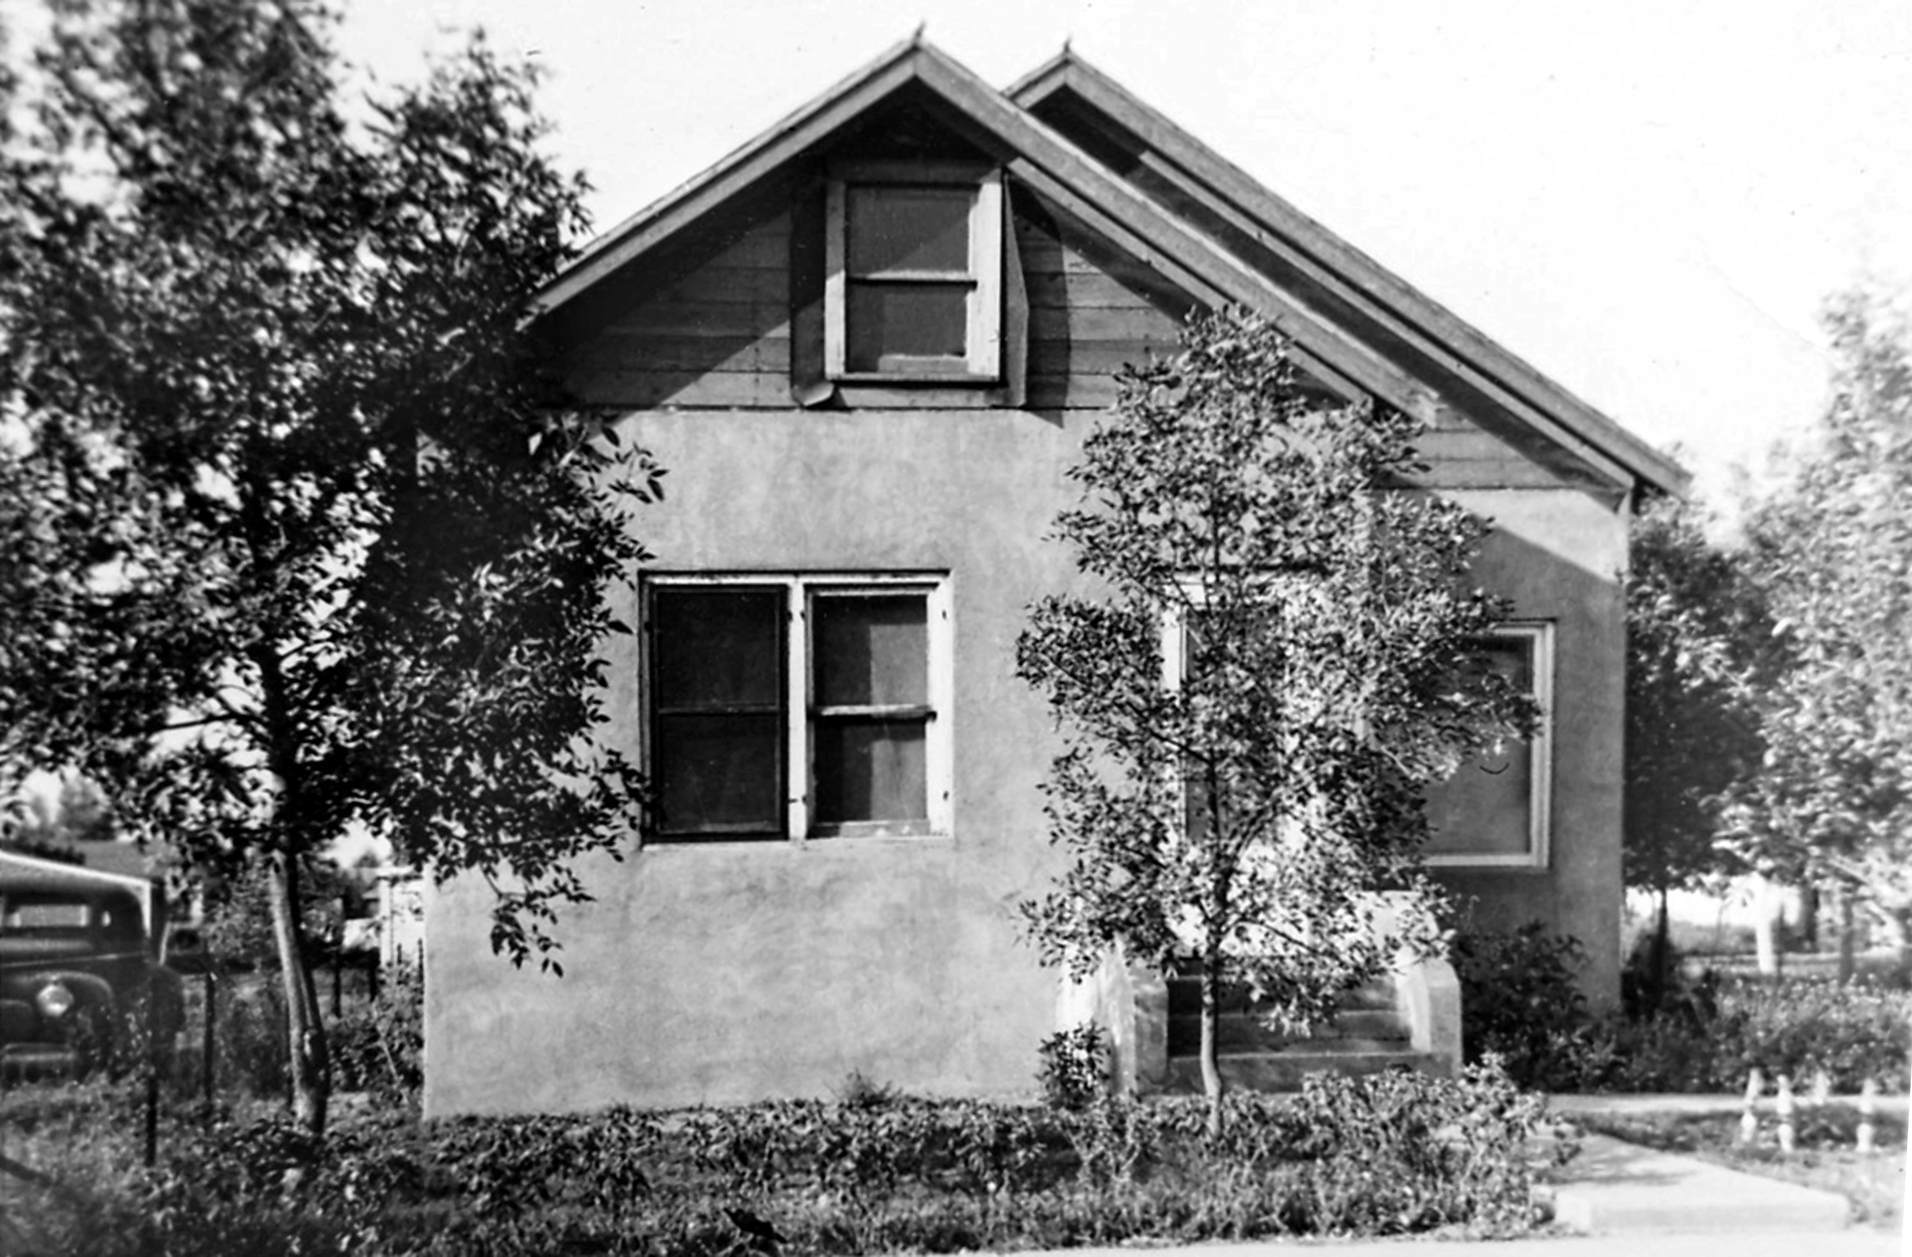

Grandma Abbey’s house before the 2nd addition was completed. I asked my Aunt Colleen why there was not bathroom upstairs with all the kids. She said my Great Grandpa Herman, who probably helped my Grandma Abbey (Mom) financially thought she didn’t need it – probably a German’s way of thinking as he came from Germany in 1883. Great Grandpa’s house was to the left of this house. He probably moved into it about the same Grandma Abbey moved into hers. He had a house in town, where the older girls would stay when they went to high school but when his wife, Frances Tavis Herman died in 1947, he downsized. Notice the car to the left. This would be his. The trees in front of Grandma Abbey’s house became nice shade trees and can be seen in other pictures.

As you walked up the stairs, to the left, was the girls’ bedroom, there were 2 double beds and 1 single bed. Colleen’s bed was next to the window. I wondered how it worked, but at times, 3 girls slept in 1 bed. Maybe 1 of the young girls slept with 2 older girls. On the opposite side of the hall was the boy’s bedroom. There were 2 double beds in this room.
More than likely Gale got 1 bed and when he left for the military, the boys each got their own bedroom. I loved this room because, there was a small cabinet-like table with a shiny copper lining. Many years later, when I had planned a 75th birthday Mass for my Grandma Abbey, she wanted me to take something. I mentioned that cabinet but then said no. Evidently my Mom liked it because she nudged me to take it. It became Mom’s and it stayed near our dining room table, filled with playing cards for an evening with family and friends to play cards. I found out it was my Great Grandpa Herman’s pipe stand. Here it is below, in 2020:

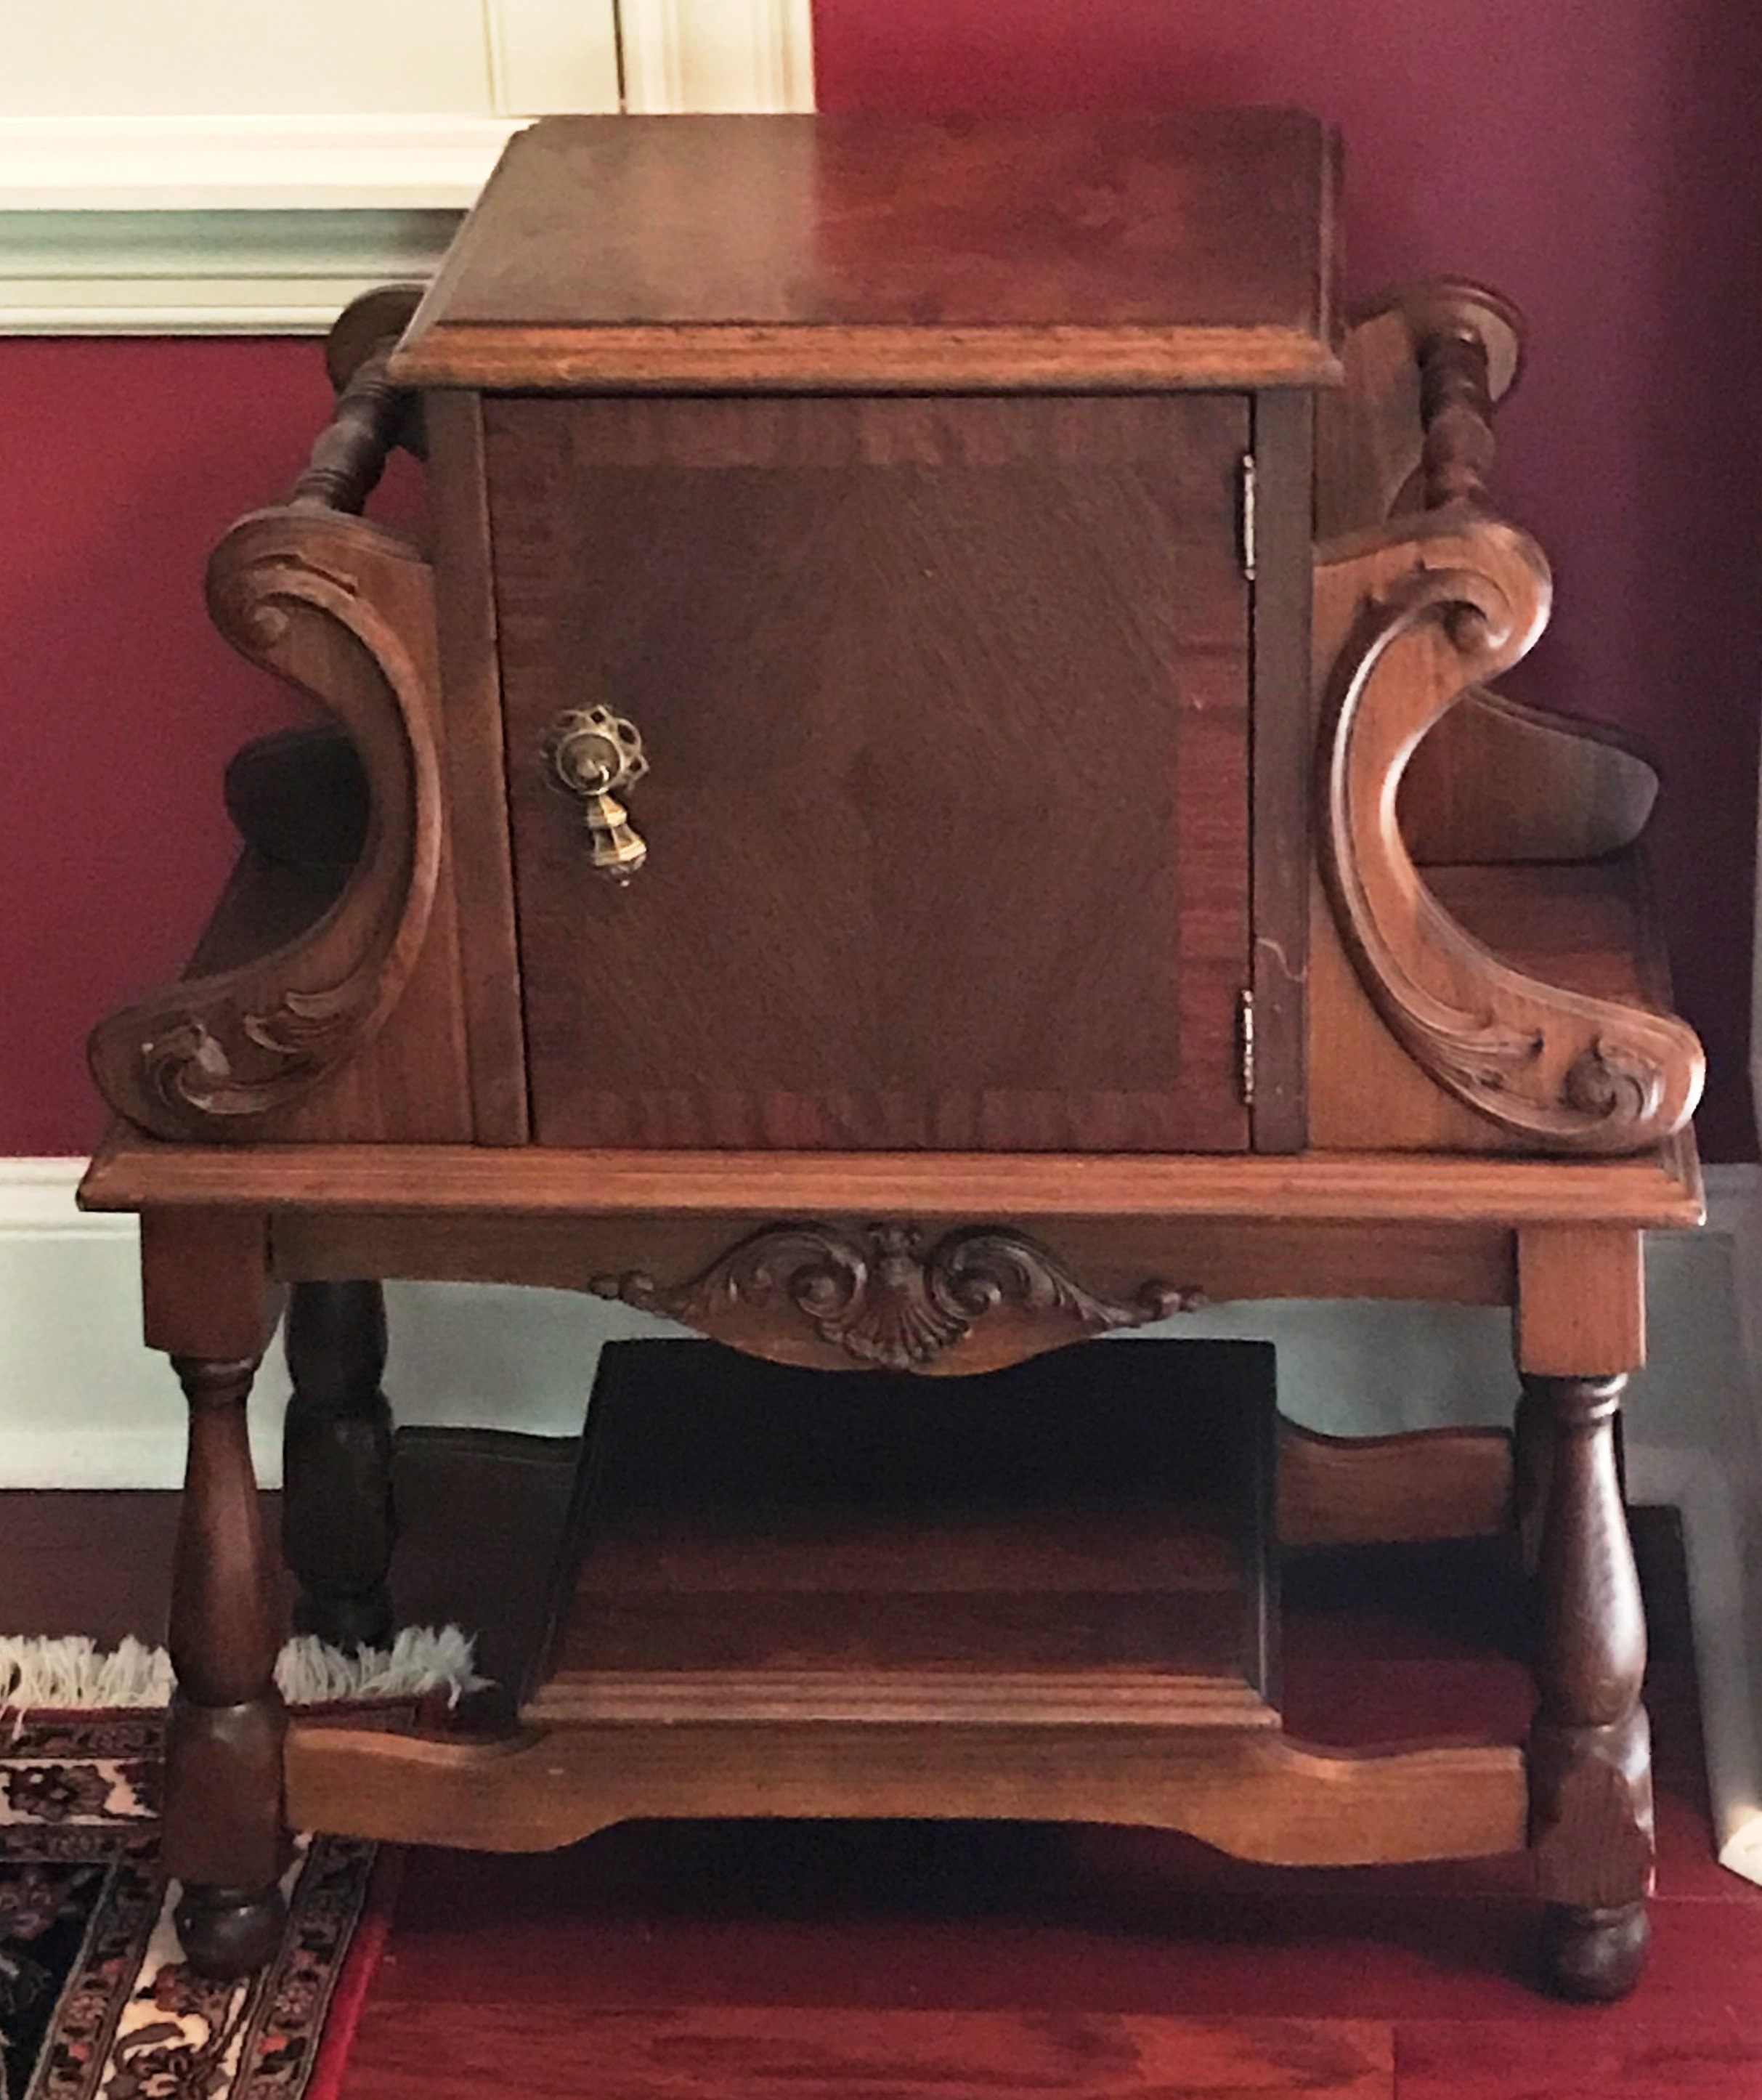

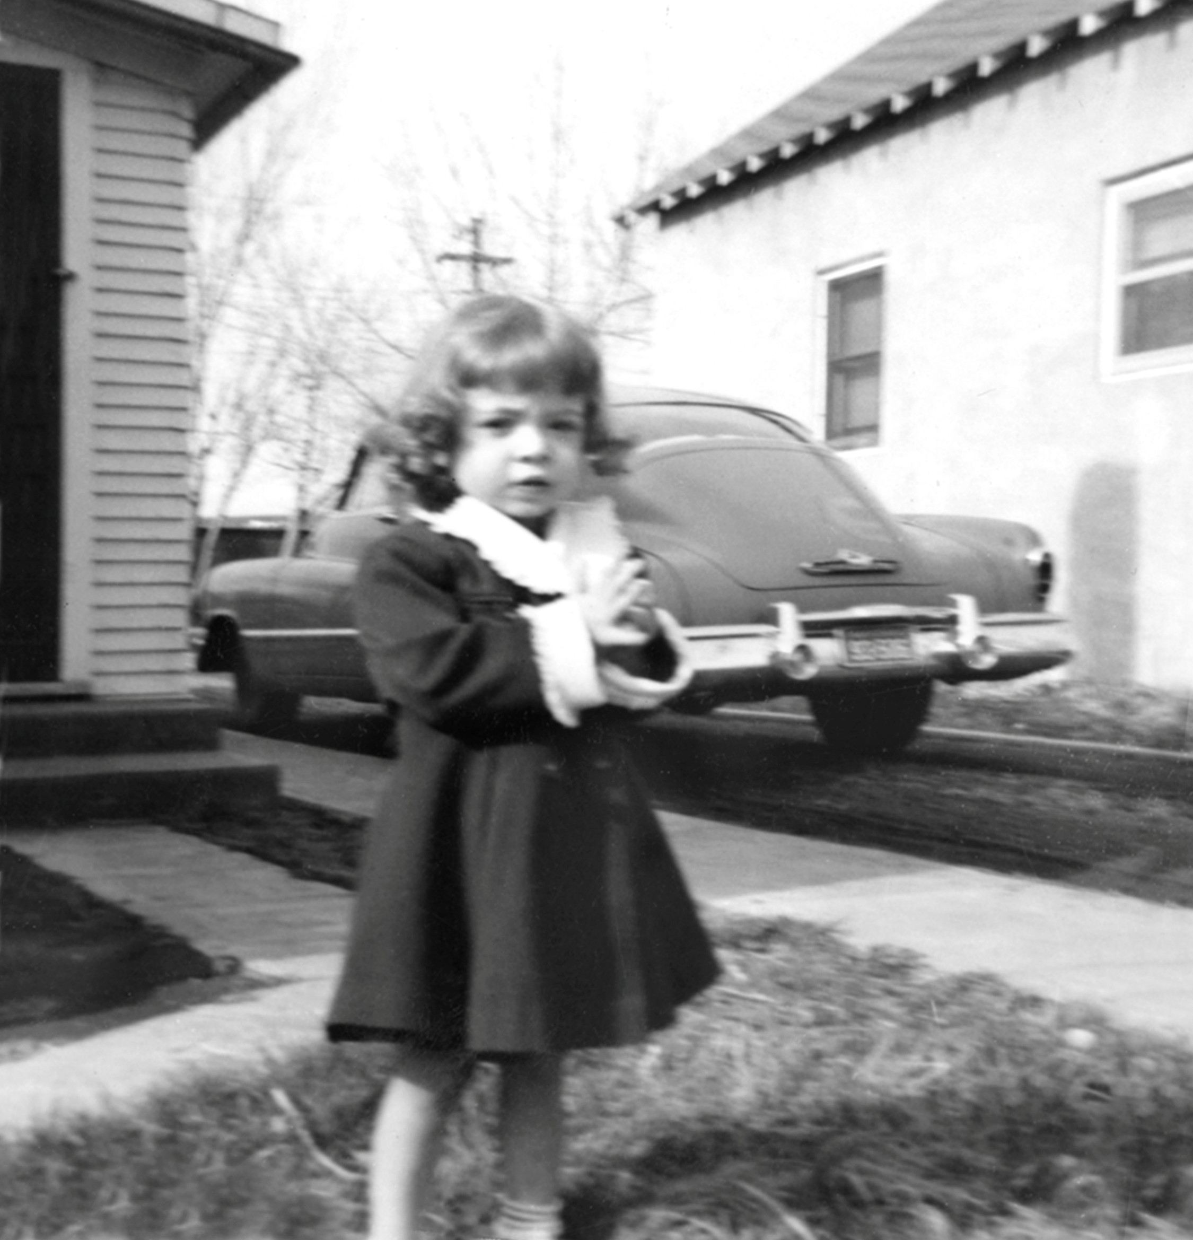

1954: Kay Wetzel in front of Great Grandpa Herman’s house. His car was blue, according to my 2nd cousin, and is sitting to the right in the picture. I loved to visit Great Grandpa and would wait until he offered me some lemon drops, sitting on the shelf in the corner. He’d offer my mother a shot of whiskey. Sometimes when we’d visit, he’d pull comics out of the attic for me to look at. It was a treat. I remember very well his death as we were at my Grandma Abbey’s home next door for the Christmas Eve meal and they had taken a meal over to him because he didn’t feel like coming over. A couple of the Abbey girls came back crying.

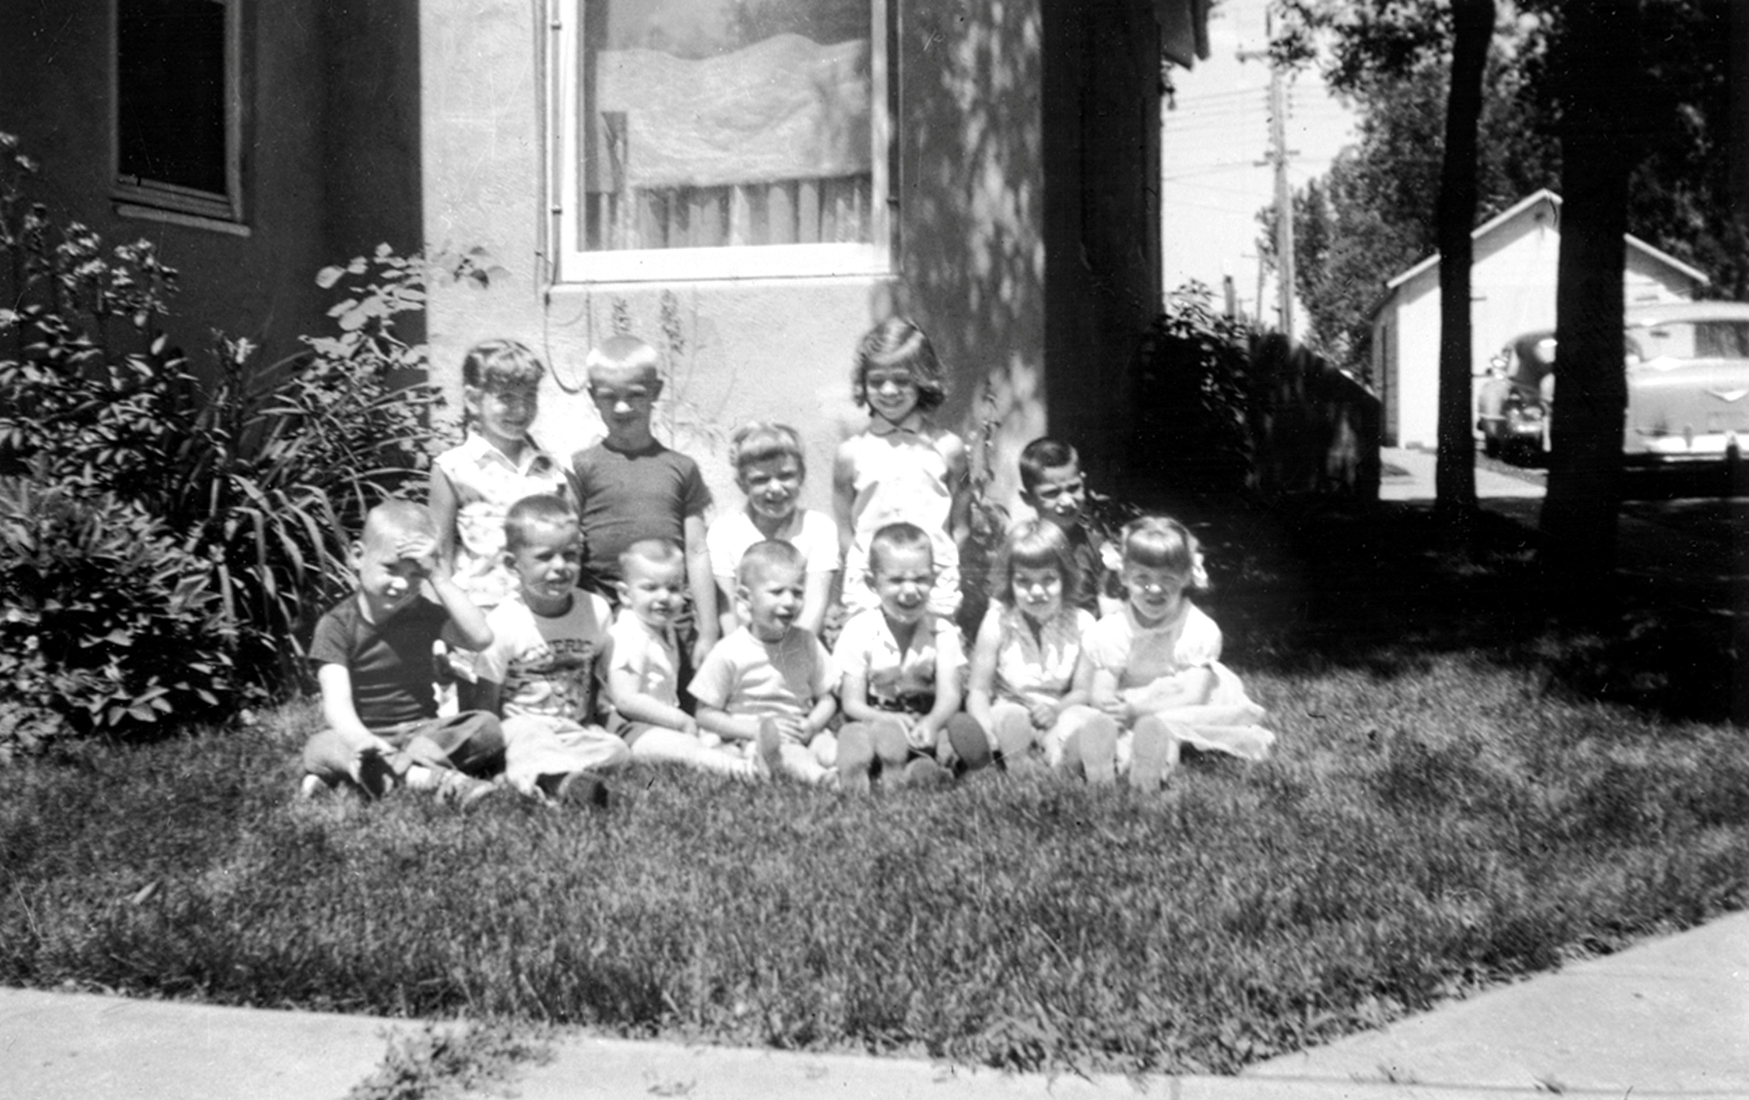

1959 Abbey children cousins
Left to Right Back row: Cindy Gustafson, Barry Wetzel, Vanessa Dolce, Kay Wetzel, Doug Lang Front Row: Kim Wetzel, Mike Dolce, Dean Lang, David Lang, Gary Dolce, Diane Lang, Jan Gustafson
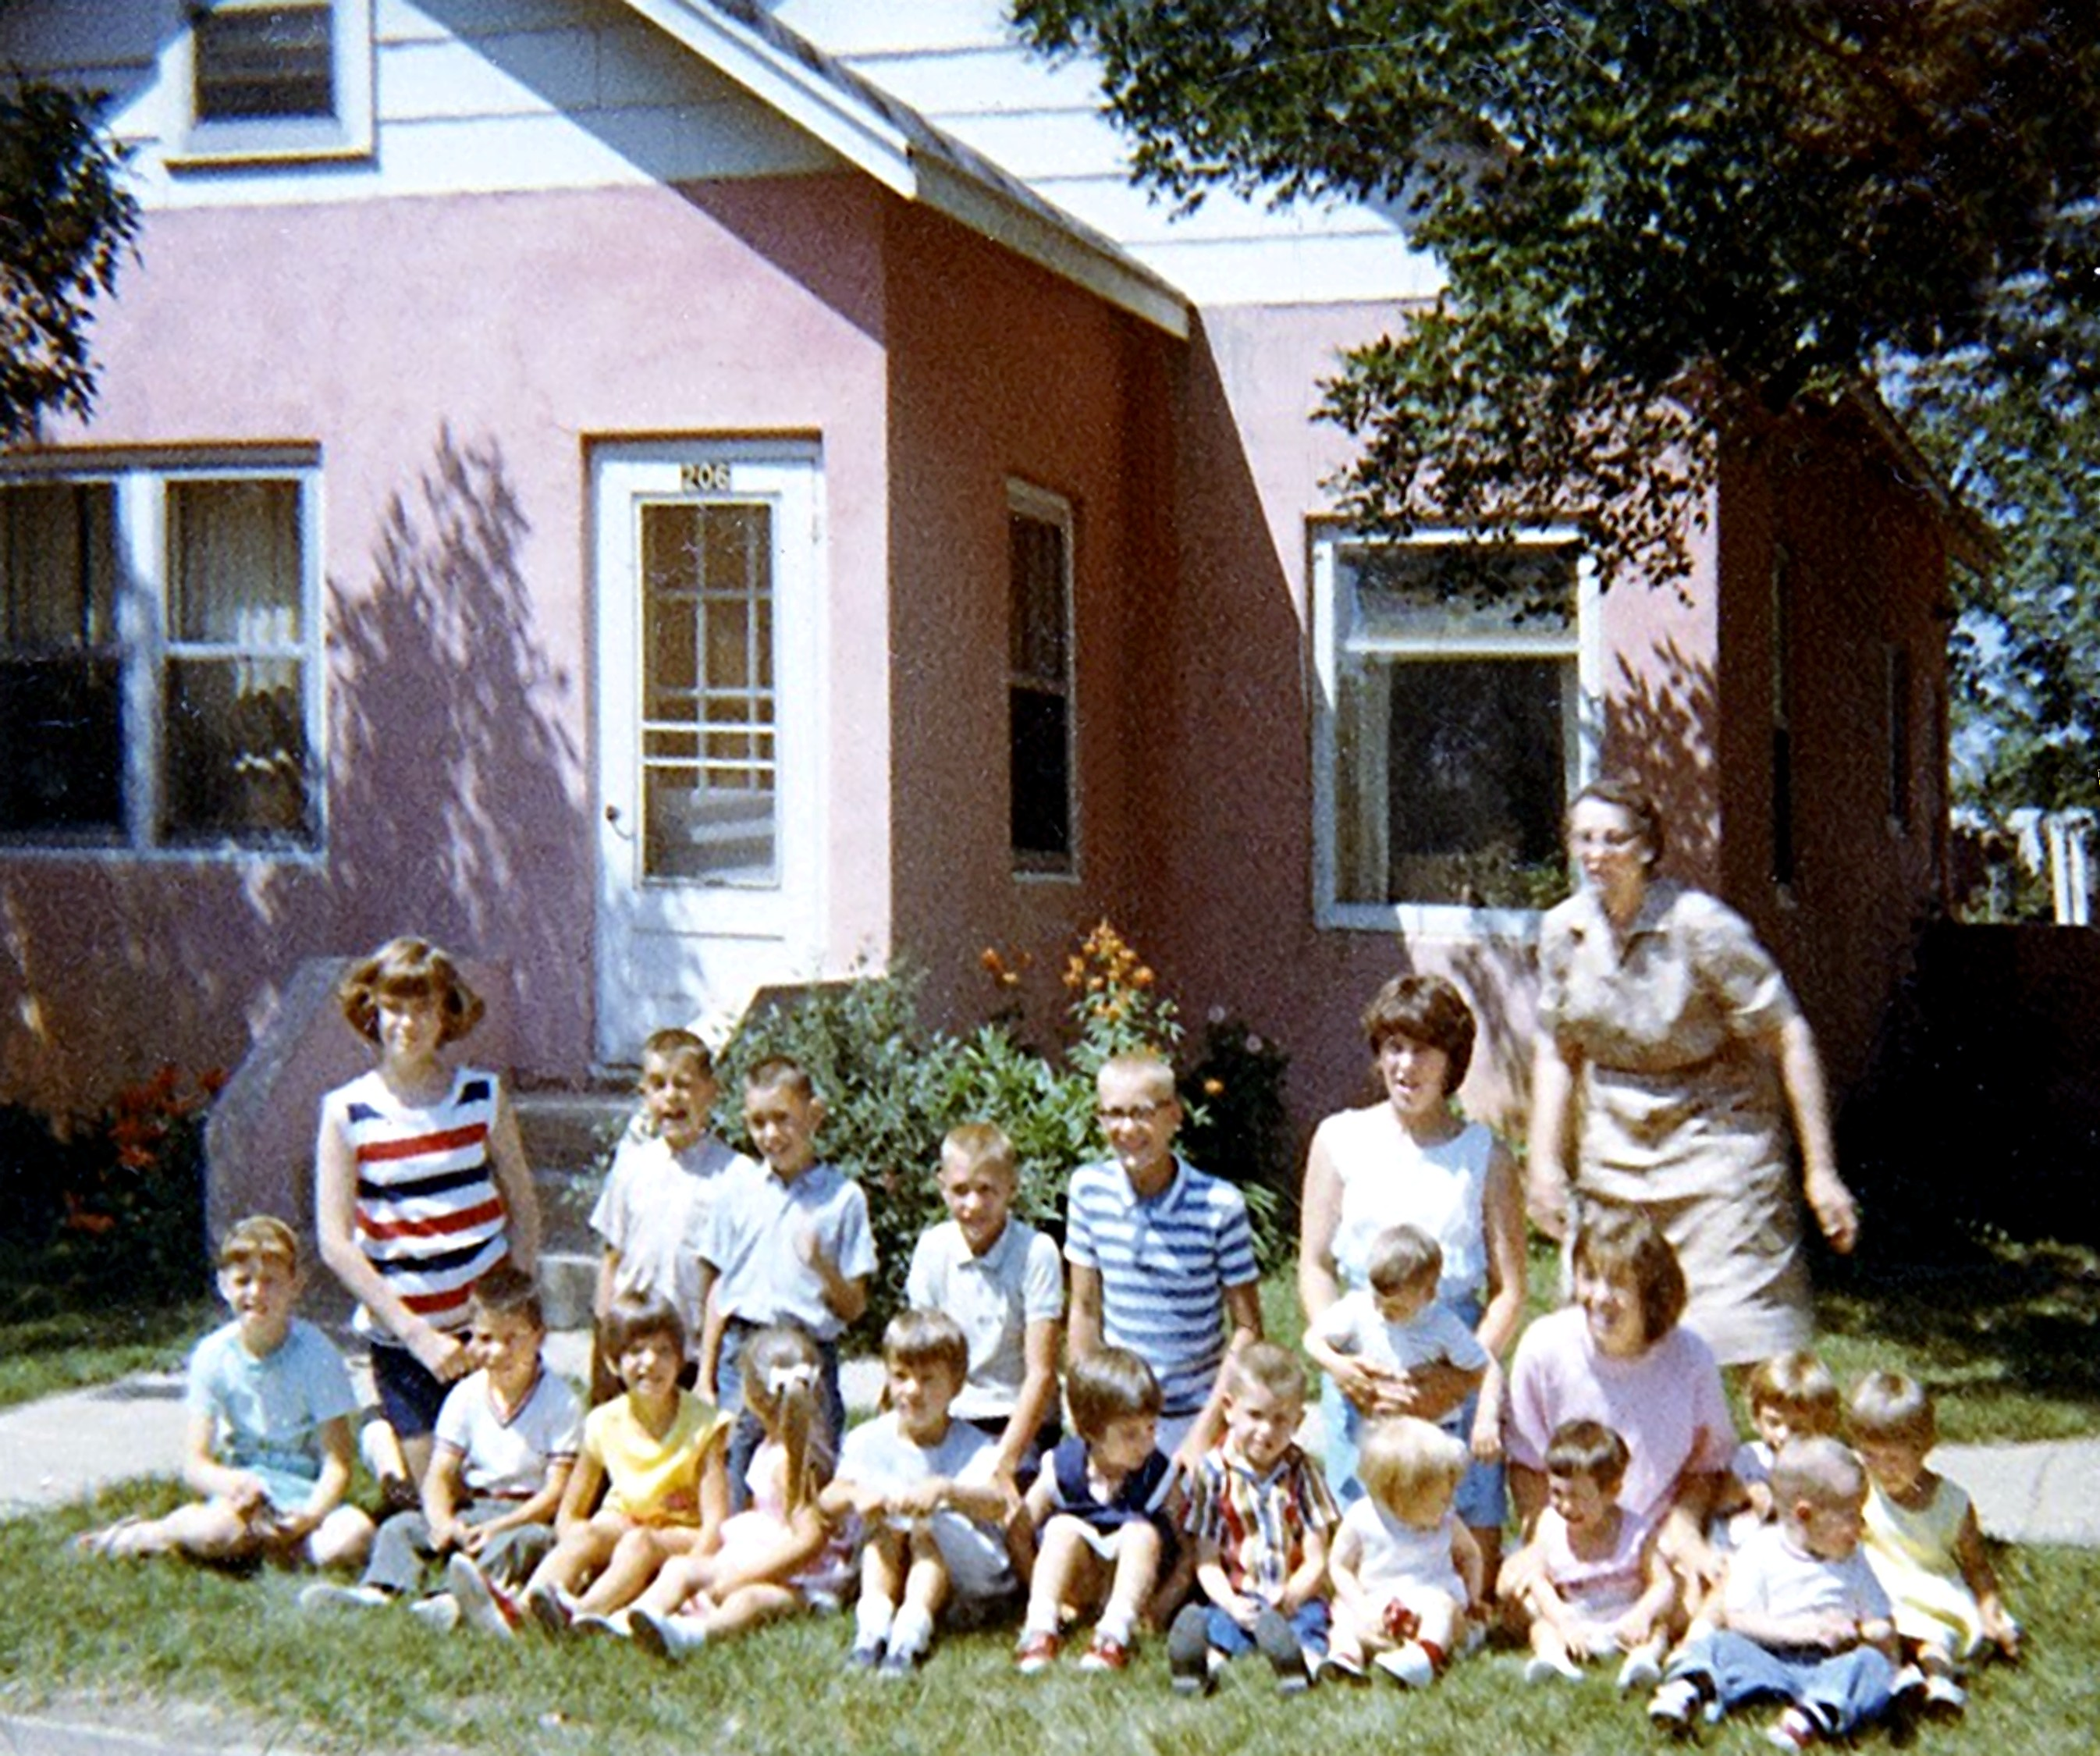

Now you can see why I called it the “Pink Frosting House”! These are the cousins in 1966, but there were more to come. In total, there were 34 grandchildren.

1966 Summer Abbey children cousins; Left to Right
Front Row: Jan Gustafson, Larry Flemmer, Denise Lang?, Tammy Dolce, Sandy Flemmer, Stephanie Stasil, Mark Gustafson, Beth Wetzel, Gina Abbey, Paul Flemmer

Back row: Vanessa Dolce, Mike Dolce, Gary Dolce, Kim Wetzel, Barry Wetzel, Cindy Gustafson holding Scott Stasil, Kay Wetzel, Marsha Wetzel, Marie Flemmer

At Grandma Abbey's house 206 East Main Street

The house was moved into about 1947, according to Colleen Abbey, when she was in the 3rd grade.

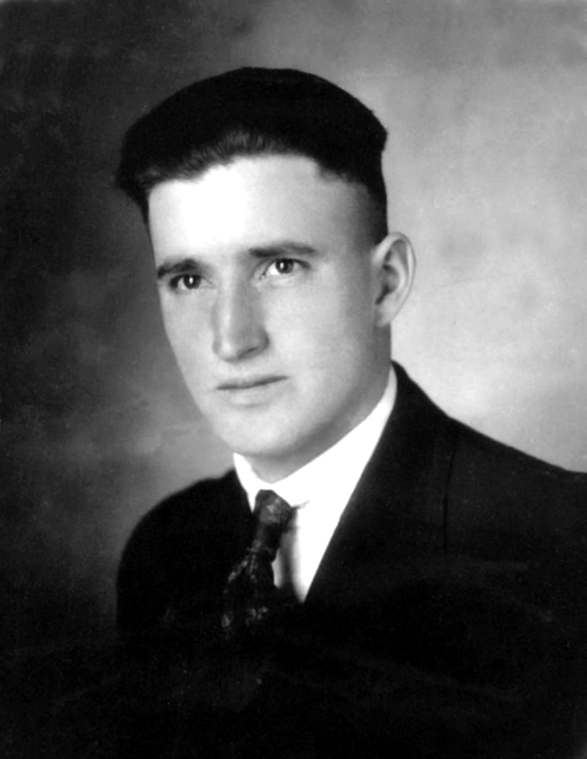

A photo of Oran Abbey, that I believe was in an oval frame in my Grandmother Alice Herman Abbey’s Living Room, above the television.

